**DAILY ONLINE ACTIVITIES SUMMARY**

|  |  |  |  |  |  |  |  |
| --- | --- | --- | --- | --- | --- | --- | --- |
| **Date:** | **9/06/2020** | | | | **Name:** | **Syed Rabeya Aamir** | |
| **Sem & Sec** | **8th B** | | | | **USN:** | **4AL16CS112** | |
| Online Test Summary | | | | | | | |
| **Subject** | | **BDA** | | | | | |
| **Max. Marks** | | **30** | | **Score** | | **25** | |
| Certification Course Summary | | | | | | | |
| **Course** | **Aws cloud practitioner essential** | | | | | | |
| **Certificate Provider** | | | **Aws** | **Duration** | | | **6 hrs** |
| Coding Challenges | | | | | | | |
| **Problem Statement:**  **1) Python program Function to print binary number using recursion.** | | | | | | | |
| **Status: Solved** | | | | | | | |
| **Uploaded the report in Github** | | | | **YES** | | | |
| **If yes Repository name** | | | | **rabeya** | | | |
| **Uploaded the report in slack** | | | | **YES** | | | |

**Online Test:**

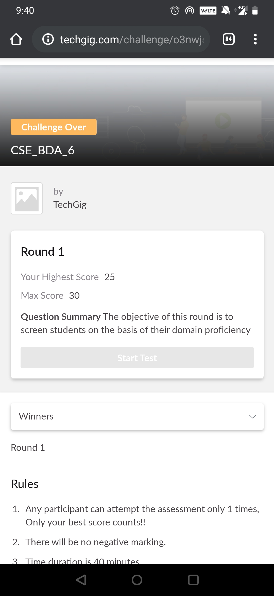

**Certification Course Details:**

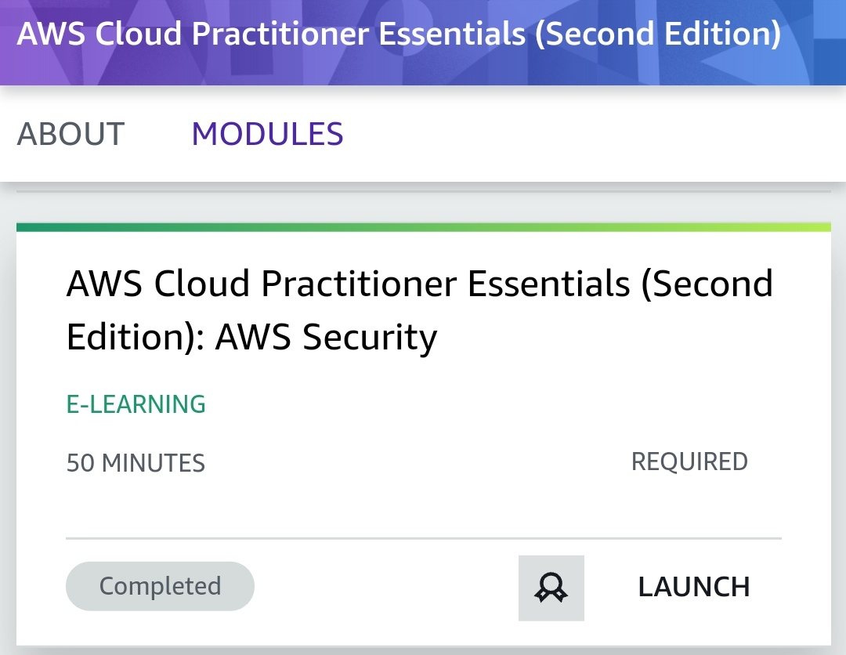

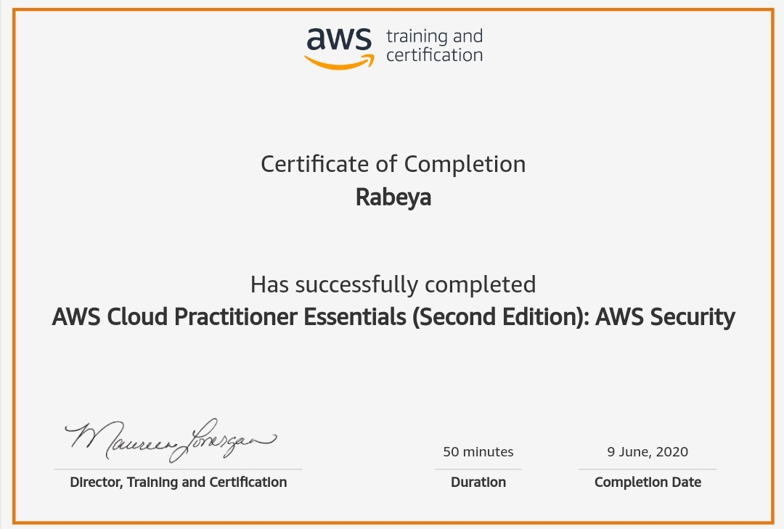

# CODE:

Program no:1

# Function to print binary number using recursion

def convertToBinary(n):

if n > 1:

convertToBinary(n//2)

print(n % 2,end = '')

dec = 34

convertToBinary(dec)

print()